**DISTRICT 112 NORTHERN NEW ZEALAND DIVISION REPORT**

|  |  |  |  |  |  |
| --- | --- | --- | --- | --- | --- |
| Division | **R** | Division Director Name  **Clifford Kerr-Phillips** |  | Report date | **31/03/2021**  **31/03/2021** |

**Division Clubs**





As at 31/03/2021 the Division has shrunk in membership from a base of 221 to 215 or by 3%. An increase by 70 members or by 33% from 215 would see the Division reach the previous peak membership achieved in 2018. However, only +6 members are required to achieve growth over the base membership of 221 with which the Division started this Toastmasters year.

DCP goals at 79 across the Division, with the mad rush that usually occurs in the last quarter still to come, looks set to surpass the 79 achieved in the 2020 year. However, note that this measure is only on a goal basis with membership of each club needing to match the required growth before than can be counted towards DCP goals.

The graph below summarizes the above.

A caveat is that these figures are before the next renewal of club fees

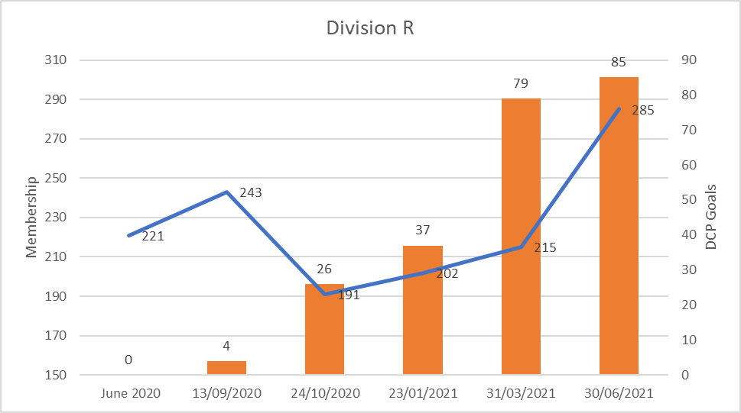

**Target**

**YTD**

**Support**

Club Coaches - what clubs have a coach appointed and what clubs still need a coach appointed?

|  |
| --- |
| Talk of the Town : David Rei Miller (Pending)  IPU NZ Toastmasters : Margaret C Simmons and Ian Hopkirk (Pending) |

Club Support – what clubs would benefit from additional support and what support is required?

|  |
| --- |
| Nothing at the moment other than assistance with Massey and Napier club membership renewals. See below. |

**New Clubs – Prospects, leads, clubs in formation**

What is the progress and what support is needed?

|  |
| --- |
| None at the moment. The Division has not had any club growth in the last 3 years. Although this remains a goal, membership retention and growth of membership numbers in existing clubs is the primary goal. |

**Division Events**

What events have been held and what feedback have you received?

For example – COT, Area or Division council meetings, Area or Division contests, workshops etc

|  |
| --- |
| * +15 Division Council meetings have been held. * The Division R International and Evaluation contests were successfully held on the 20/03/2021 * An outstanding feature of the Evaluation Contests were the international test speaker organised by Neville Isherwood. Neville had also organised international test speakers for each of the three Area Evaluation Contests. * I also enjoyed the manner in which the 3 ADs came together in assisting each other in the preparation and execution of their International and Evaluation Contest. It is also appropriate to mention the support Neville provided to each of his fellow ADs and me as Division Director in the management of these contests at the Area and Division levels. * As set out in the table above, 4 clubs did not reach the threshold of 4+4 officers trained, however the Division R 2nd COT was well run and received. |

What events are being planned?

|  |
| --- |
| A joint decision was made not to participate in the Relay for Life event in PN. Having just come out of two Level 3 and 2 Lock downs which occurred in quick succession it was decided to not proceed with the organisation of this event. |

**Challenges**

What challenges is the Division facing and what potential solutions/assistance is needed?

|  |  |
| --- | --- |
| **Issues** | **Solutions** |
| Massey Toastmasters Club | Has 5 members paid up with 4 waiting to be paid by AgResearch. Until the reports roll over need to chase this to avoid manual process. |
| Napier | Have no members paid up. Experienced technical issues. Strong Club. Until the reports roll over need to chase this to avoid manual process |
| Annual Business Meetings at club level | Follow up with ADs to ensure awareness of this function. |
| Succession | Follow up with ADs to ensure awareness of this function.. |
| Ensuring that next executive club committees are set up prior to the year end. | Follow up with ADs to ensure awareness of this function.. |